

CS516 - Computer Vision

Prof. Russell Butler

Students

Bhoopalsinh Musale 002269332

Sara Eskandarirad 002279327

**Part 1: Joint histogram 10/100**

* Completed all.
* We have not shown all the images output in this pdf but it’s written in code.

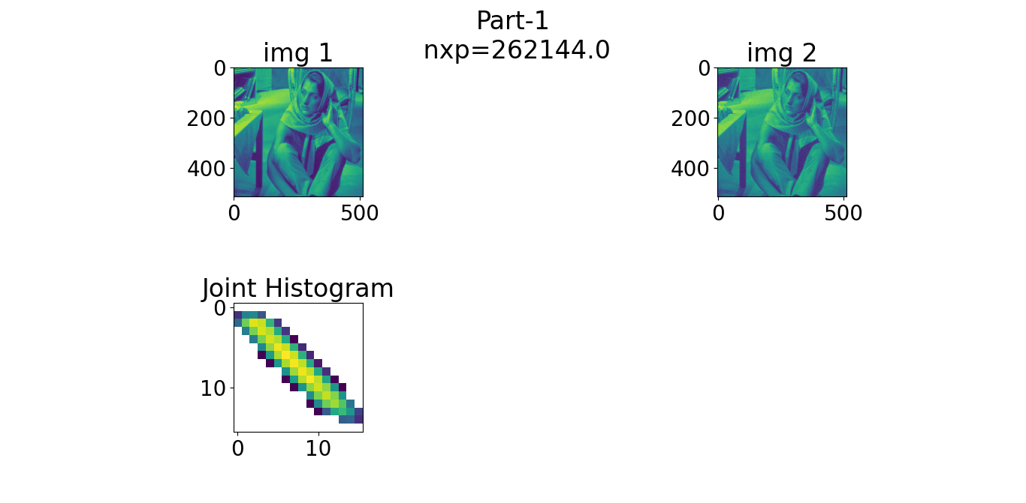

**Part 1(C) Observation:**

* I1 and J1 are similar in terms of both grayscale and position, as a result, most points in the histogram center around the line `y = x`, with minor deviations due to the "blurred effect". I2 and J2 are also perfectly aligned with respect to pixel positions, but have slightly different grayscale intensities, therefore, we observe a line with a different slope and intercept, while the data points are still closely clustered. I3/J3 and I4/J4 show the images of two different people. Since the images are less similar to each other, data points in the histogram are more scattered around. This pattern is also observed in the last two pairs of images where a slice of brain is shown. However, the details of the brain are greyed out in J5 and J6 using a constant intensity around 100. Consequently, many data points overlap on the vertical line `x = 100`, where the grayscale intensity on the y axis ranges from roughly 10~140, corresponding to the intensity within the brain as in I5 and I6.

**Part 2 (similarity criteria 20/100):**

* completed all parts.
* No output to show in this question.
* The more similar two images are, the larger the mutual information value is. The first two pairs of images share a lot of similarity, so the mutual info values are higher. The second pair only differs in grayscale intensity, so this pair has the highest mutual info. In the first pair, J2 is a little blurred, so the mutual info drops a bit. All other pairs have a significantly lower mutual info because they are much less similar.
* The Pearson correlation coefficient fails to detect any non-linear relationship, so it's does not give us

very useful information. For example, both the third and the fourth pair have different images, so the pearson coefficient should be similar, but it turns out that they differ a lot simply due to random shapes or noise.

* The squared sum difference is also not a good metric when it comes to image similarity. For example, while the first two pairs of images are very similar, its ssd is very high. The next two pairs of images are not similar at all, but they have a much much lower ssd. In fact, if we transform an almost black image into a almost white image, the difference on each pixel will be very large, despite the similarity of the two images, the corresponding ssd will still be a tremendous number.

**Part 3 (spatial transforms 20/100):**

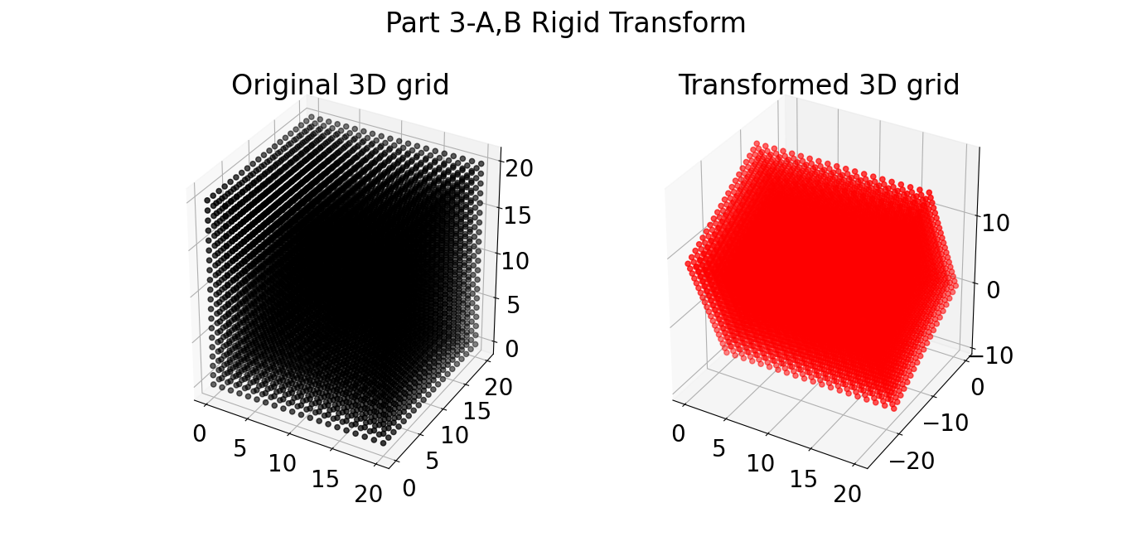

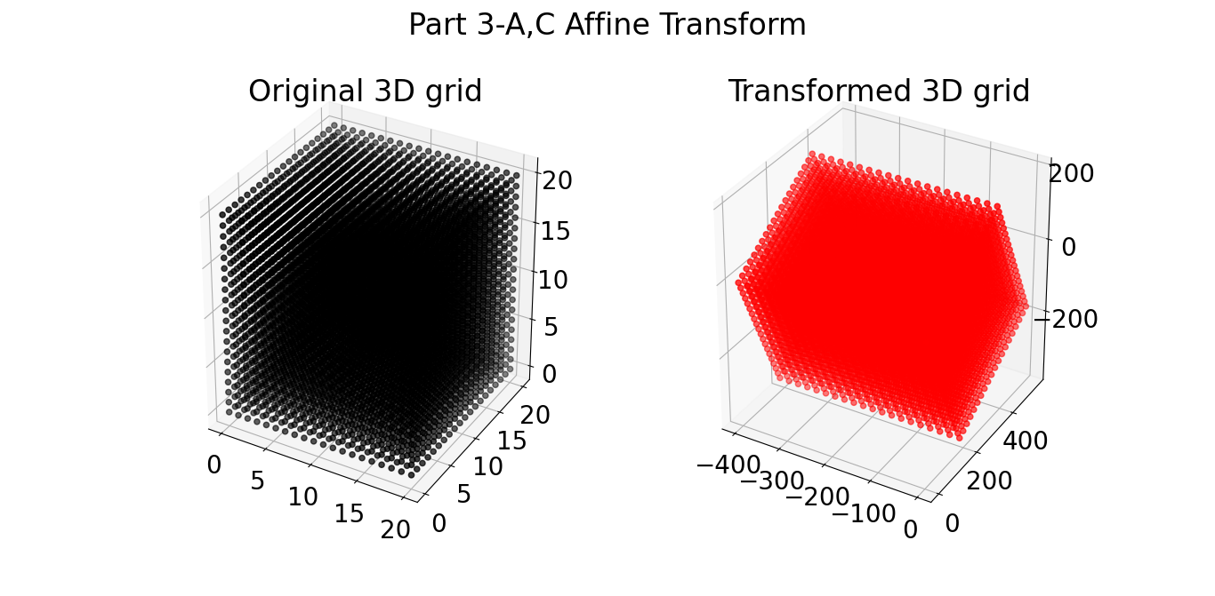

**Part 3(D) : (not done)**

**M1=**

**M2=**

**M3=**

* **Bonus question:** +10% how did I create Mystery image (below)? Explain what the contrast is based on.

**An**s=> It is produced using gaussian blur filter on “bold.nii” modality, with very high sigma value around 150. Which is then plot with “gray” colormap.